1.Create a simple Scrum Board for a 'Food Delivery App Testing' project using a spreadsheet or online tool (like Trello or Miro), with columns for Backlog, To Do, In Progress, and Done. Add at least 6 testing tasks such as 'Login Functionality Test', 'Order Placement Test', and 'Payment Gateway Test'.

ANSWER:-
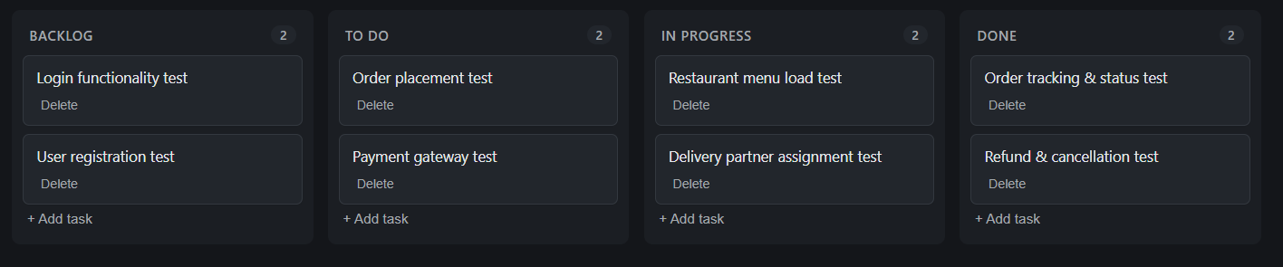

2.Write a short description of what happens during a Sprint Review in Agile, and explain how the testing team contributes to this meeting using an example from any app you use (such as Zomato or Instagram).

ANSWER:-
A sprint review happens at the end of every sprint, where the whole team, including product owner and stakeholders, comes together to see what was actually completed during that sprint. the team demonstrates the working features that were built, not just talks about them, so everyone can see real progress.
how testing team contributes:-
the testing team shares what features were tested during the sprint, what bugs were found and fixed, and what still needs more testing. for example, if the team was working on Zomato's "schedule order for later" feature, the testers would demo that the feature works correctly, mention any edge cases they tested like scheduling for a time when the restaurant is closed, and flag if any bugs are still open so the team knows the feature isn't fully ready yet.

3.List 5 typical Agile testing activities that would happen during a 2-week sprint for a new feature in a popular app (for example, adding 'Dark Mode' to WhatsApp). For each activity, mention which Scrum Board column it would appear in at the start of the sprint.

ANSWER:-
1 writing test cases for dark mode UI — this would appear in the To Do column at the start of the sprint, since test cases need to be written before actual testing can start.
2 testing dark mode on different screens (chat, settings, calls) — this would appear in the Backlog column at the start, since it depends on the feature being built first.
3 checking if text is readable in dark mode across all screens — this would appear in the Backlog column at the start, since it's part of testing that happens once development is more complete.
4 reporting bugs found in dark mode, like icons not changing color properly — this would appear in the Backlog column at the start, since bugs are only found once testing actually begins.
5 retesting fixed bugs before sprint ends — this would appear in the Backlog column at the start, since it can only happen after bugs are reported and fixed.

4.Pick any one feature from an app you use daily (like 'Add to Cart' in Flipkart or 'Stories' in Instagram) and break it down into at least 4 test tasks that would be tracked on a Scrum Board. Assign each task to a specific sprint day and explain your reasoning.<br><br><em><strong>Hint:</strong> Think about functional, UI, and integration testing for the feature.</em>

ANSWER:-
Here we going take Flipkart's "Add to Cart" feature and break it down into test tasks across the sprint days.
1 Day 1-2: write test cases for add to cart — this is done early in the sprint so the team knows exactly what will be tested once the feature is ready.
2 Day 3-4: functional testing (adding, removing, changing quantity of items) — this happens once the core feature is built, to check if the basic actions work correctly.
3 Day 5-6: UI testing (cart icon updates, item image and price display correctly) — this comes after functional testing, since it makes more sense to check the visuals once the core functionality is confirmed working.
4 Day 7-8: integration testing (cart connects properly with payment and wishlist features) — this is done later in the sprint, since it depends on other features like payment and wishlist also being ready to test together.

